# CS 255 System Design Document Template

This template lays out all the different sections that you need to complete for Project Two. Each section has guidance to prompt your thinking. You will need to continually reference the interview transcript as you work to make sure that you are addressing your client’s needs. There is no required length for the final document. Instead the goal is to complete each section based on what your client’s needs are. Remove this note when you are finished, and replace all bracketed text with the relevant information.

## UML Diagrams

### UML Use Case Diagram

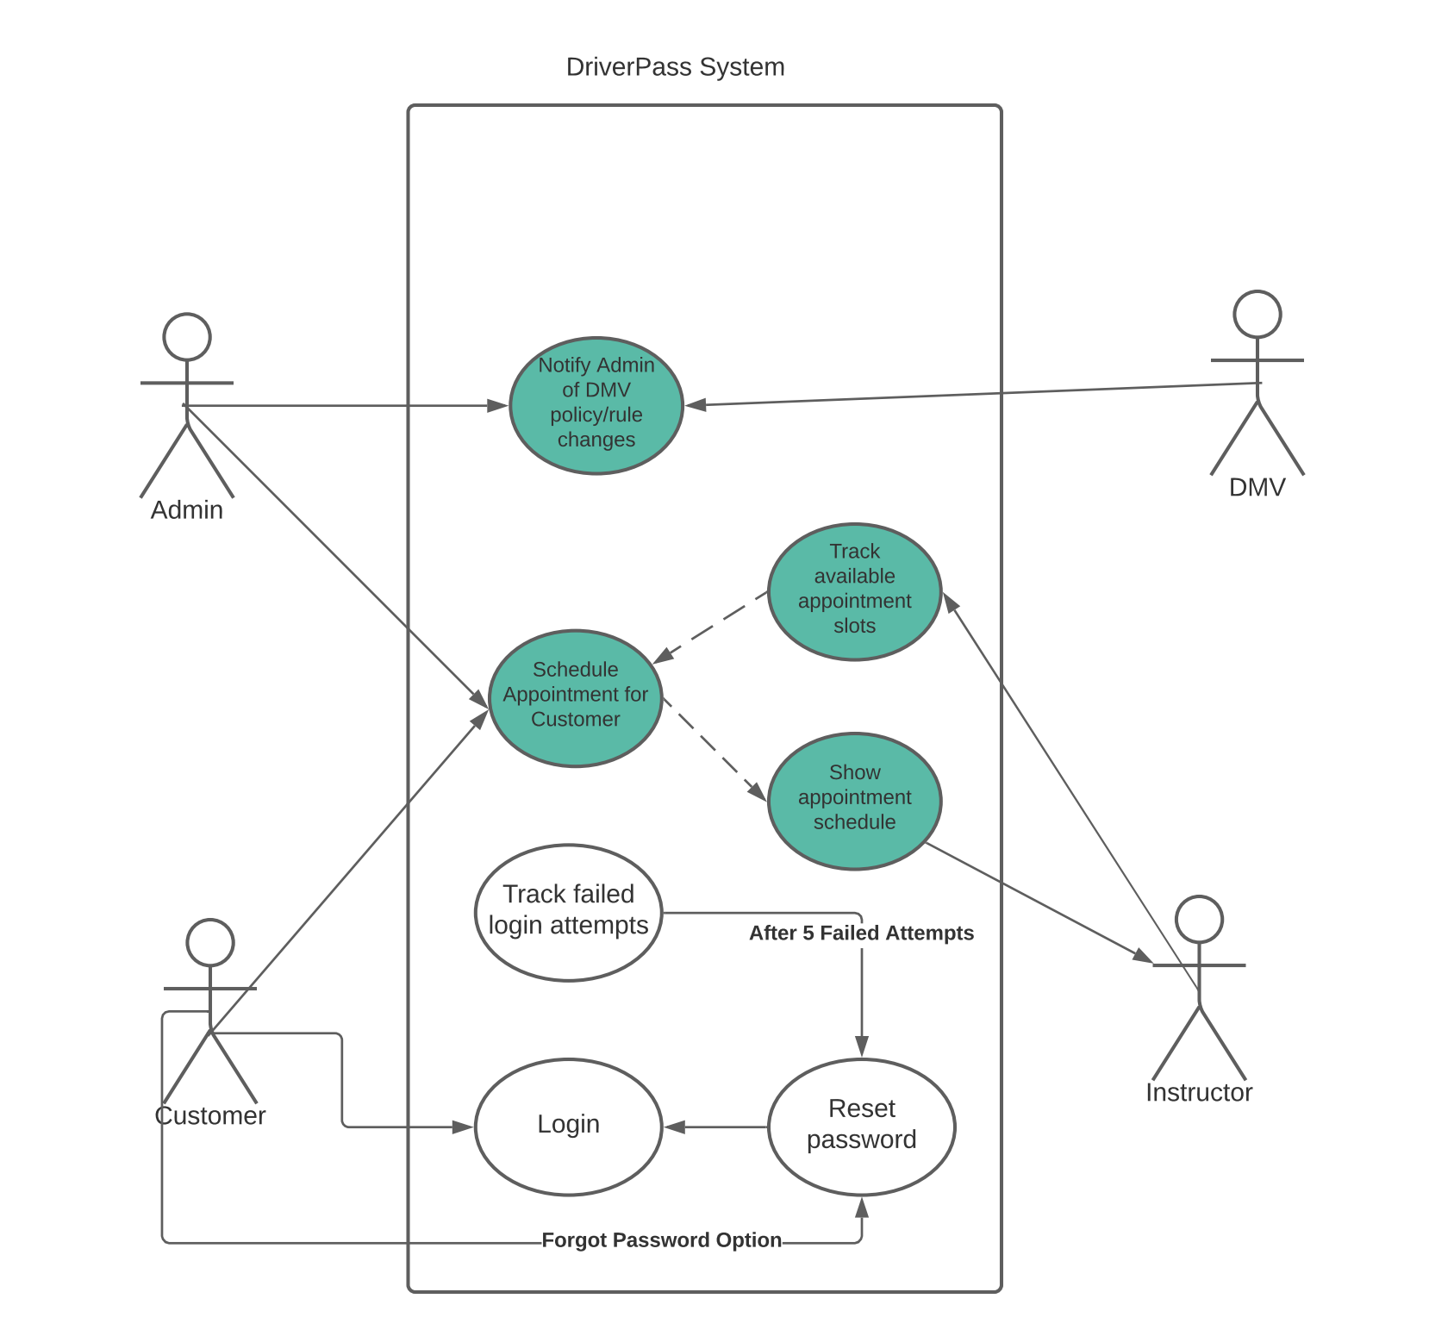

### UML Activity Diagrams

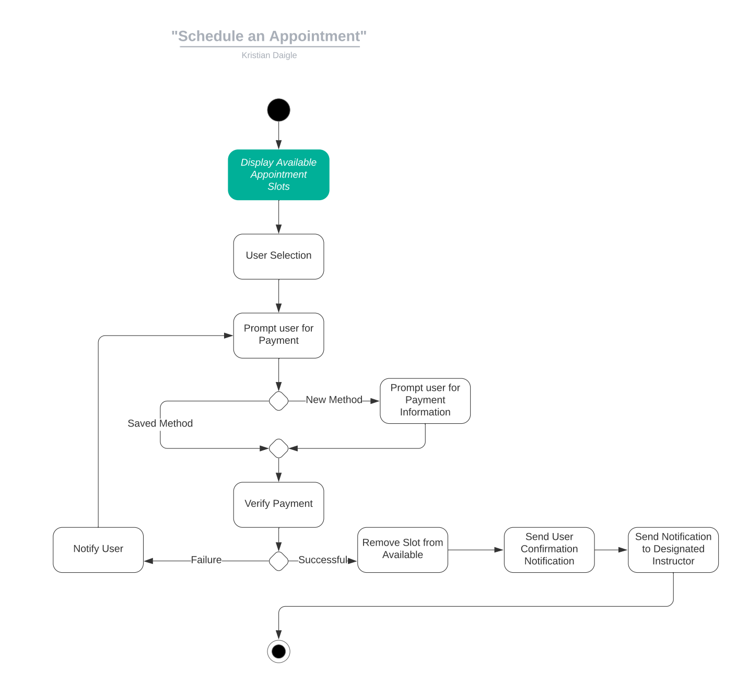

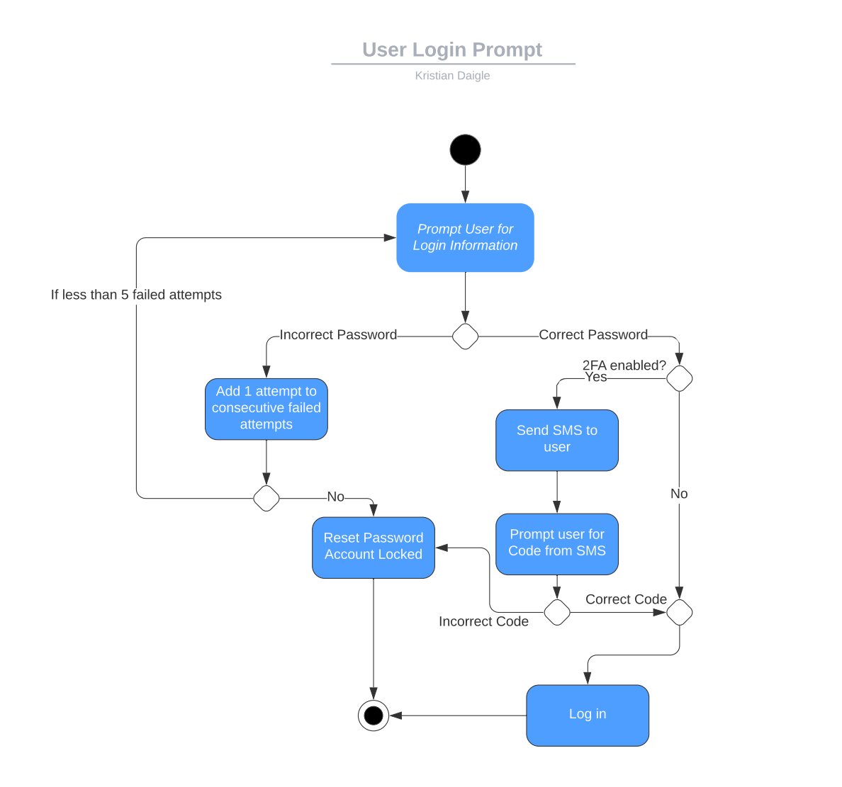

### UML Sequence Diagram

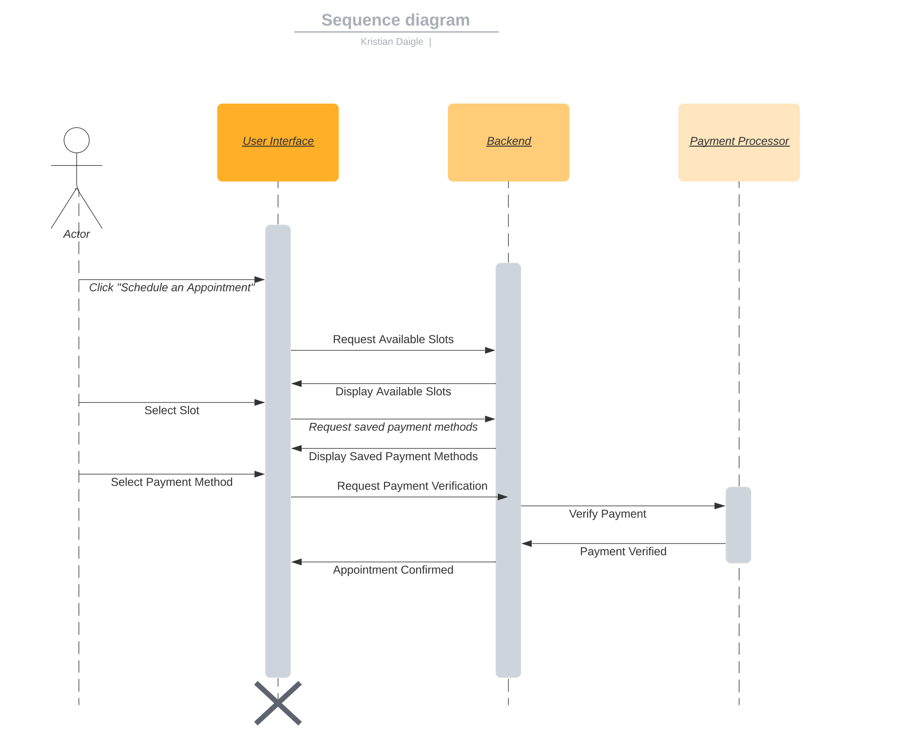

### UML Class Diagram

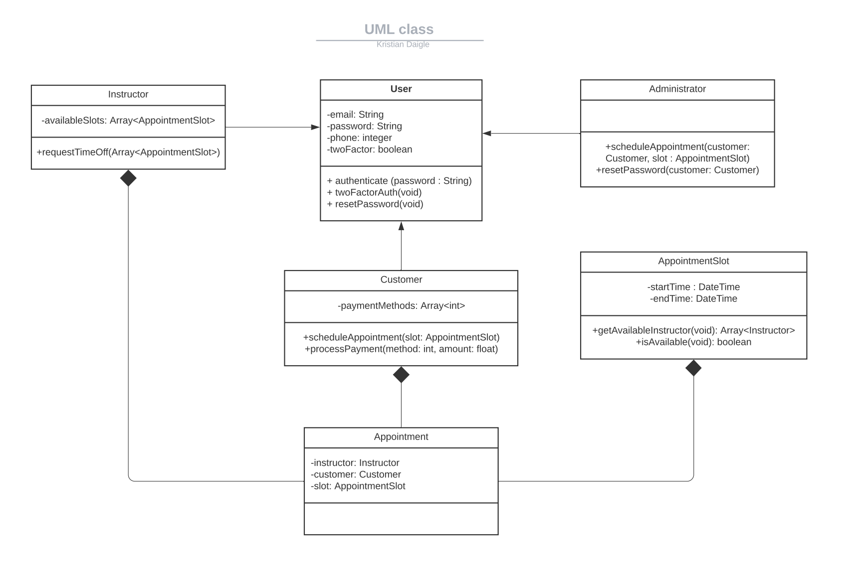

## Technical Requirements

*This system will require a machine to run the backend database. This will require consistent internet. This will keep track of all of the appointments available, the web interface, etc. Additionally, we will need to take advantage of some sort of payment processing service such as PayPal, Square, or something similar. The users/admin will need a computer with internet connection and a browser available to access the interface also.*